

**FACULTY OF ENGINEERING TECHNOLOGY.**

**GROUP MEMBERS: SARFARAZ KAIM KHANI.**

**M. SHAHBAZ KHAN.**

**ROLL NO: 2K18-ELE-97**

**DEPARTMENT: BS-ELECTRONICS**

**SUBJECT: COMPUTER VISION**

**ASSIGNED BY: DR, SUNDER ALI KHOWAJA.**

**Digital image processing sobel edge detection:**



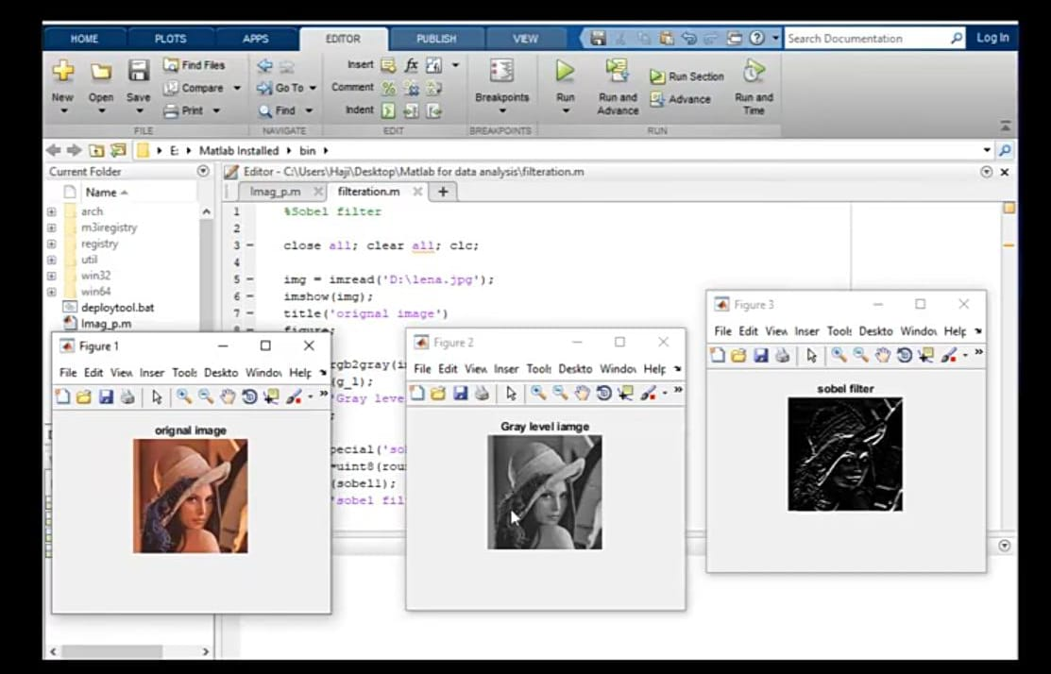

1. **Original Picture:**

I = imread('cameraman.tif');

J = imcomplement(I);

imshowpair(I, original')

It shows an actual picture of vision to enhace the vintage in other images.

1. **Grey Picture:**

I = rgb2gray( RGB ).

The rgb2gray function converts RGB imagesto grayscale by eliminating the hue and saturation information while retaining the luminance.

1. **Edge Picture:**

BW = edge( I , method )

An edge in an image is a significant local change in the image intensity, usually associated with a discontinuity in either the image intensity or the first derivative of the image intensity.

**Working:**

The Sobel filter is used for edge detection. It works by calculating the gradient of image intensity at each pixel within the image. It finds the direction of the largest increase from light to dark and the rate of change in that direction.Edge detection is an image processing technique for finding the boundaries of objects within images. It works by detecting discontinuities in brightness. Edge detection is used for image segmentation and data extraction in areas.